**19CSE435 – COMPUTER VISION**



**GROUP-10. Anomaly Detection in college environment**

**TEAM DETAILS**

JAHNAVI ANALA - CB.EN.U4CSE21024

MANTHINI MEHER VARDHAN - CB.EN.U4CSE21034

NERELLA GEETHA KRISHNA - CB.EN.U4CSE21040

TANGUDU HARSHA VARDHAN - CB.EN.U4CSE21062

**Essential techniques for feature detection and description:**

|  |  |  |
| --- | --- | --- |
| STUDENT NAME | ASSIGNED ROLE | FEAUTRE DESCRIPTOR |
| JAHNAVI ANALA | Tracking - Monitoring objects or elements as they move across frames in images or videos, utilizing algorithms like snake algorithm or optical flow algorithm. | ORB |
| MANTHINI MEHER VARDHAN | Dataset (Images and Videos) - Describing scenes in images and videos to provide context. | HARRIS CORNER |
| NERELLA GEETHA KRISHNA | Matching - Enhancing images, converting color modules, identifying key frames, and utilizing computer vision algorithms for tasks like denoising. | GOLF |
| TANGUDU HARSHA VARDHAN | Detection - Identifying elements within the images/videos, including feature detection and algorithm implementation. | SIFT |

**SIFT:**

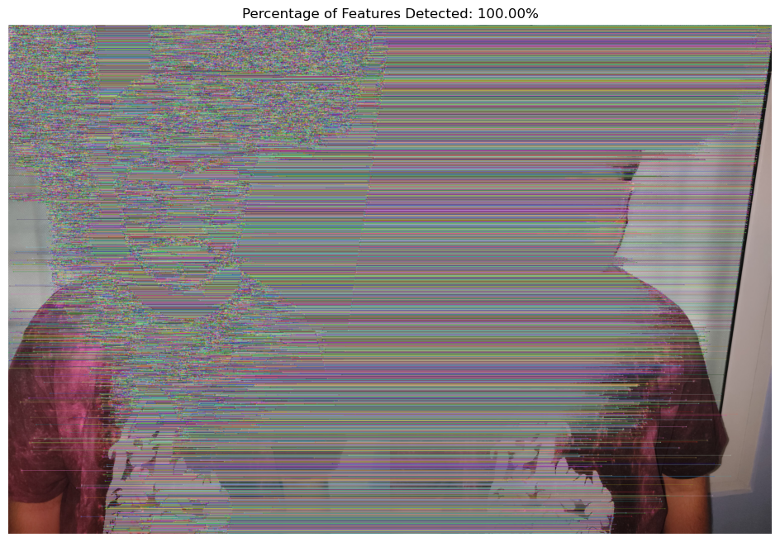

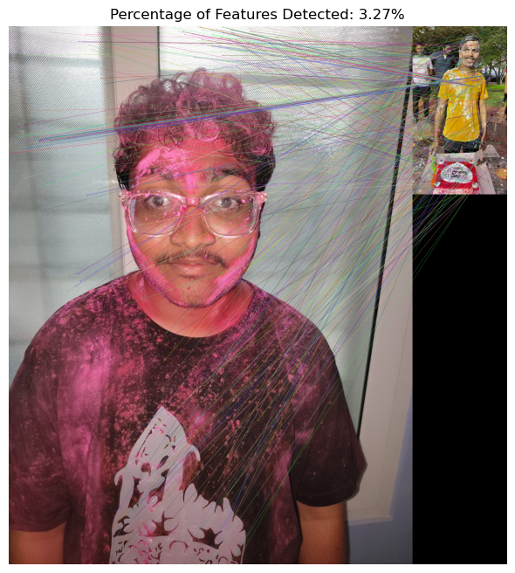

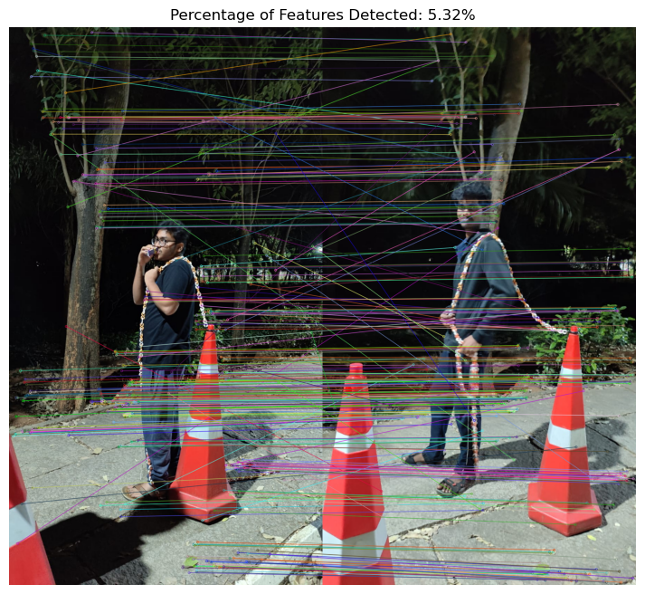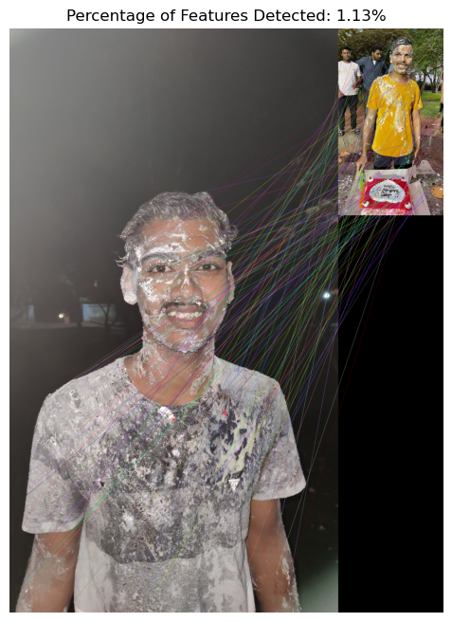

**ORB:**

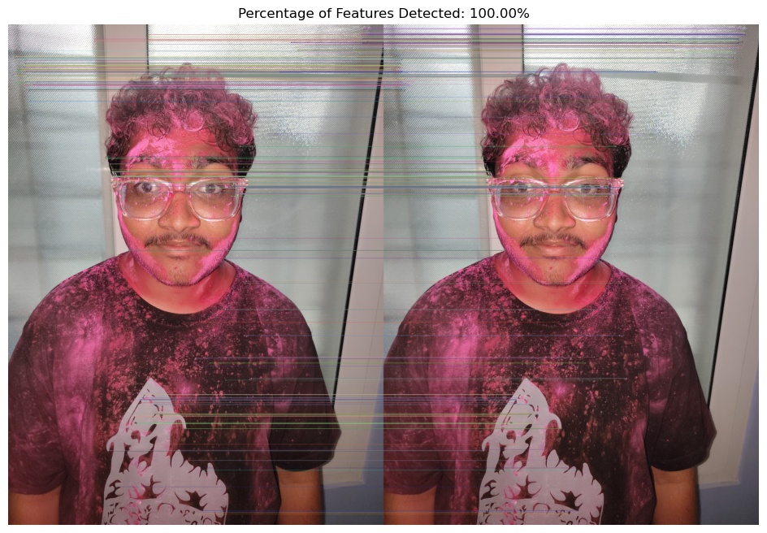

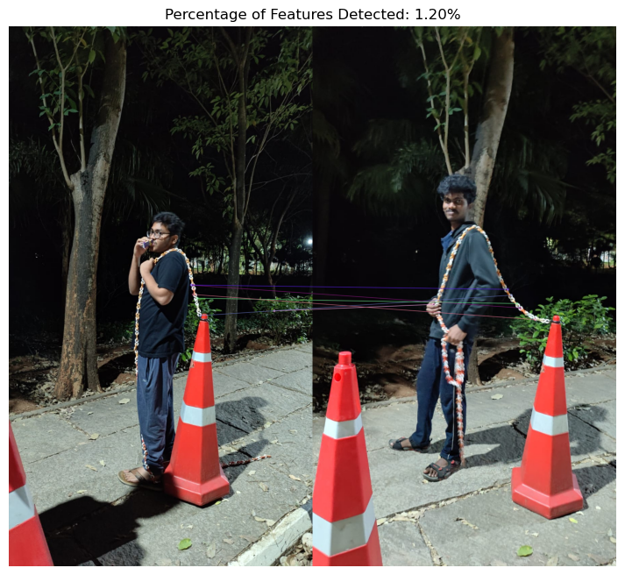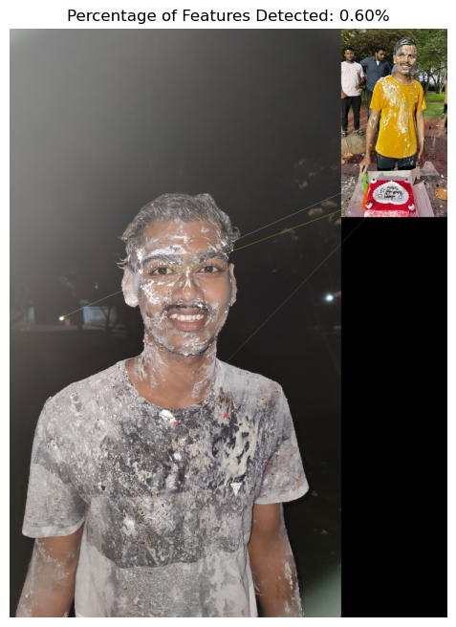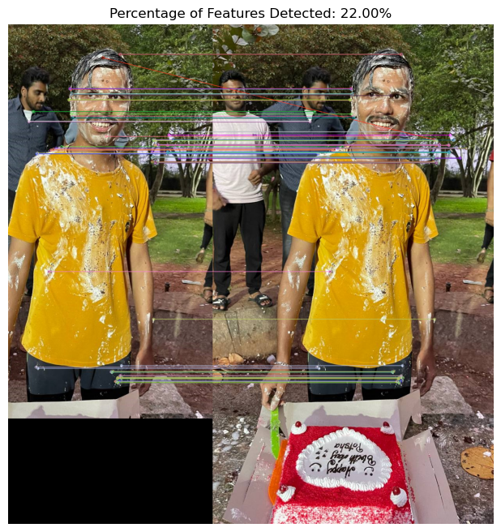

**HARRIS CORNERS:**

